Tiddlywinks

Preschool Newsletter

Sept 2021





Welcome back! Hope you had a lovely Summer

**Dates for your Diary**

**INSET DAYS**

**OCT 22ND**

**NOV 22ND**

**JAN 4TH**

**HALF-TERM**

**OCT 25TH-29TH**

**CHRISTMAS BREAK**

**DEC 18TH-JAN 3RD**

**BACK TO SCHOOL**

**JAN 5TH**

**FEB HALF-TERM**

**FEB 21ST-28TH**

**EASTER BREAK**

**APRIL 11TH-22ND**

**MAY HALF-TERM**

**MAY 30TH-JUNE 7TH**

**LAST DAY OF SCHOOL**

**JULY 21ST**

**Butterfly Room**

It is very exciting to see all our old and new friends back in the room.

This term, we are focusing on number recognition and sequencing for 1-10. We will use lots of fun activities to help support this learning in the setting.

We are also very excited to announce that we will be doing yoga on Mondays and Fridays, so please be sure to have your children in loose fitting clothing those days.



**Caterpillar Room**

This term we will be focusing on supporting our new children to settle into the group and make new friends quickly. We will continue to engage in small group work to promote listening and attention skills, and learn each others’ names. We will be reading different stories with repeated refrains, creating displays, and experimenting with different ways of creating art work.

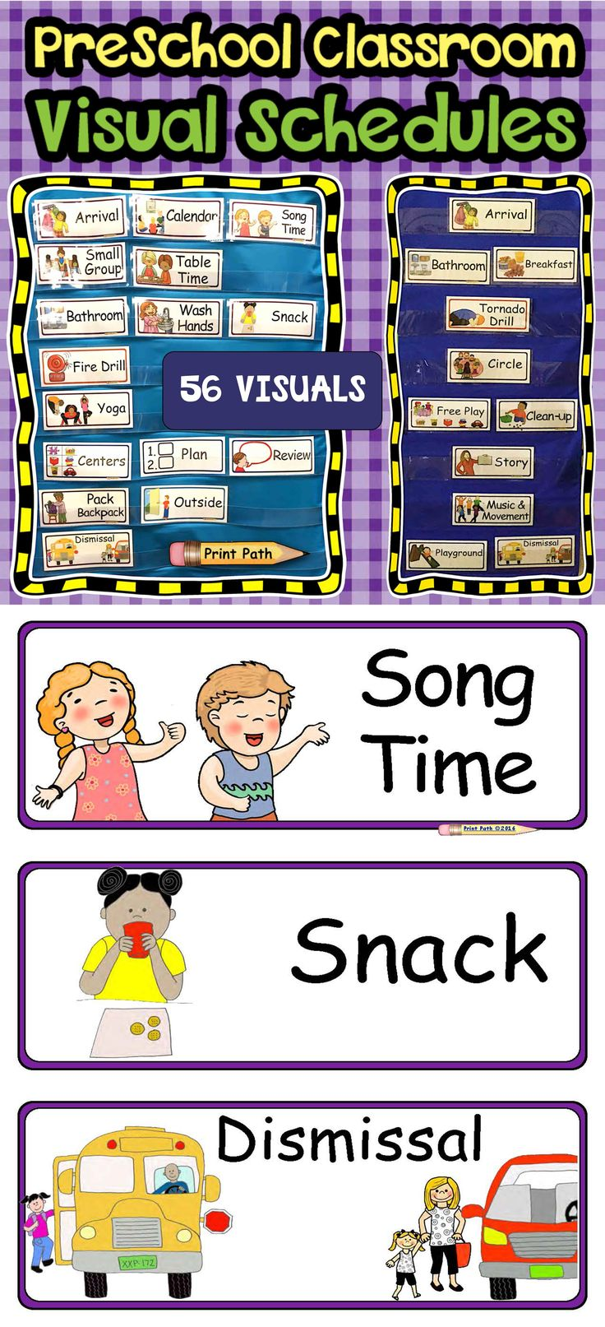

Tapestry

Tapestry has gone through a major update to include the new EYFS curriculum guidelines.

You may see a delay in observations and pictures of your child’s day, as we familiarise ourselves with the new system. We hope to have content ready for you by 3rd week of Sept.

**Reminders:**

*Please be sure to label children’s bottles, lunch boxes and coats

*A reminder that we are a nut-free school, so please no nuts, nut butters, etc in lunches.

*We are continuing our one-way system, so please be sure to exit through the lunch room at pick up and drop off.

*If you could also bring a pair of wellies for rainy days, please do.

Labelling!