Tiddlywinks Newsletter

Jan 2020

Topic-Music



Tiddlywinks Newsletter

July 2014

Summer Term 2 – People Who Help Us

Tiddlywinks Pre-School

Alder Drive

Ambrosden

Bicester

OX25 2RD

01869 256555

In order to make our own instruments, we are asking for any donations of old butter tubs, yoghurt pots, and other recyclable plastics.

**Dates for your diary**

**Term 3**

**Tues 7th Jan- Fri-14th Feb**

**Term 4**

**Mon 24th Feb- Fri 3rd Apr**

**Term 5**

**Tues 21st Apr-Fri 22nd May**

**Term 6**

**Tues 2nd June-Tues 21st July**

**Please note the following days are INSET days and we are CLOSED-**

**20th APRIL**

**1St JUNE**

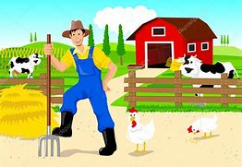

**Farmer Gows trip coming in May!**

**Fun, Family BBQ coming in July- details to come.**

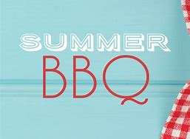

Butterfly Room

This term we will be learning different types of music and how to create our own music using instruments we make ourselves. We will also be listening to different sounds we can make and move along to.

We will also continue to work on numbers e.g. recognising numbers, counting etc.

We are already starting our preparations for the ‘Big School’ too! For those whose child is moving up to the ‘Big School’, we ask the parents to encourage their children putting on their own shoes, coats etc. It is also important to teach the children independence in ‘selfcare’ skills- toileting and hand washing.

Caterpillar Room

This term we are looking at the music and movement.

We will be exploring all different kinds of sounds found all around us. We will also be experimenting with movement to music in many different ways. The children are already enjoying having the instruments out to play!



**EVENTS!**

We have a lot of events coming up. They are as follows...

PARENTS EVENING

Monday 30th March 3:30-5:30

(timeslots will be on the parent’s board soon)

Easter Arts and Crafts with Egg hunt

Thursday April 2nd 4:00-5:30



**Thank You!**

Thank you for your generous contributions to both Children in Need and Bags2school. We raised £42.25 for Children in Need and saved over 100kg of clothes from the tip!



Labelling!